30

In this circuit, the bulb is lit.

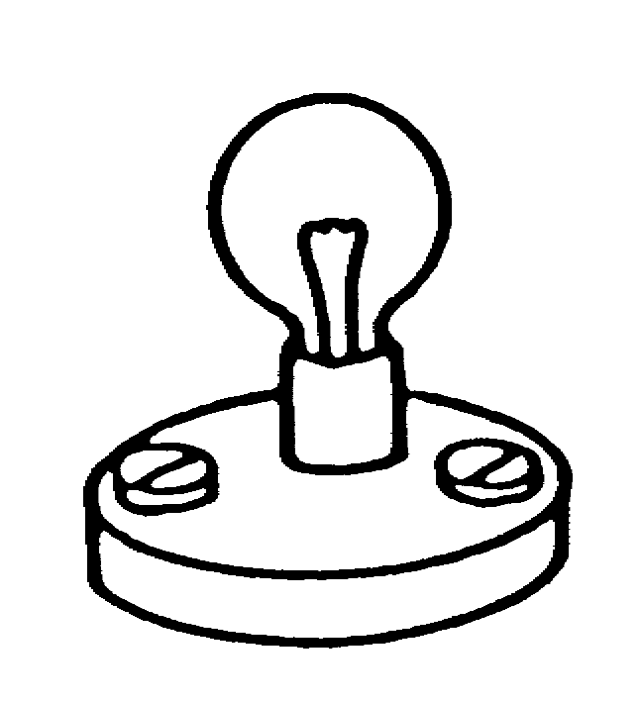
current
wire B
wire A
Battery

The circuit is left switched on for several minutes. The bulb stays lit all the time. Its brightness does not change.

Read each of the statements below and put a tick () in one box to show if you think it is correct or incorrect.

 | correct | don’t know | incorrect
(a) There is now less electric charge stored in the battery than there was at the start. | ❑ | ❑ | ❑
(b) There is now less energy stored in the battery than there was at the start. | ❑ | ❑ | ❑
(c) The battery now contains less electric current. | ❑ | ❑ | ❑
(d) The voltage of the battery is less than it was. | ❑ | ❑ | ❑
(e) The power of the battery is now less. | ❑ | ❑ | ❑
(f) The battery now contains less electricity. | ❑ | ❑ | ❑

